AWS CodeBuild Hands-on: Build Source Code from a GitHub Repository

Overview
you learned how to manage source code using Git and repositories such as GitHub or AWS CodeCommit.

Step 1: Create a GitHub Repository
- Log in to your GitHub account.
- Click New Repository.
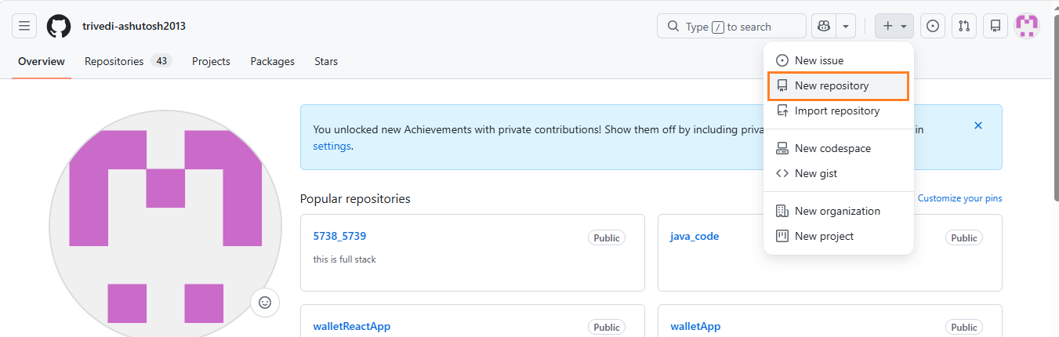
- Enter a repository name (for example, codebuild-demo).
- Create the repository.
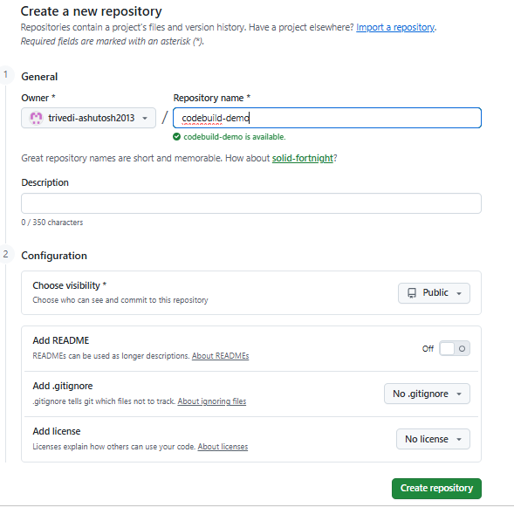
This repository will store the application source code that AWS CodeBuild will build.

Step 2: Initialize a Local Git Repository
- Open your terminal and create a new project directory.
mkdir codebuild-demo

cd codebuild-demo

git init

- Copy your application source code into this directory.
- Verify the files are present before committing them.

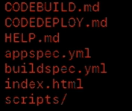

Step 3: Commit the Source Code
- Stage and commit the files.
git add .

git commit -m "Initial CodeBuild project"
- Rename the default branch.
git branch -M main

Step 4: Connect the Local Repository to GitHub
- Add the GitHub repository as the remote origin.
git remote add origin https://github.com/<username>/codebuild-demo.git

- Push the code.
git push -u origin main

- If prompted for authentication, generate a GitHub Personal Access Token (PAT) and use it instead of your GitHub password.
- After the push completes successfully, verify that all files are visible in your GitHub repository.

Step 5: Open AWS CodeBuild
Navigate to:
- AWS Console → CodeBuild
- If this is your first time using CodeBuild, you'll see the Get Started page describing how AWS CodeBuild compiles, tests, and packages your application.
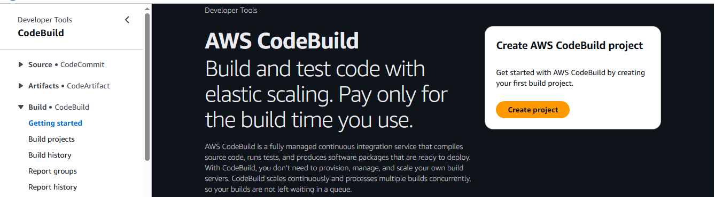

Step 6: Create a Build Project
- Click Create Build Project.
Provide the following details:
- Project Name: MLOps-demo
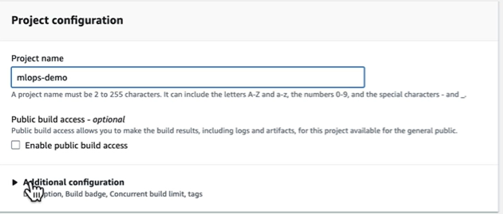
- Source Provider: GitHub
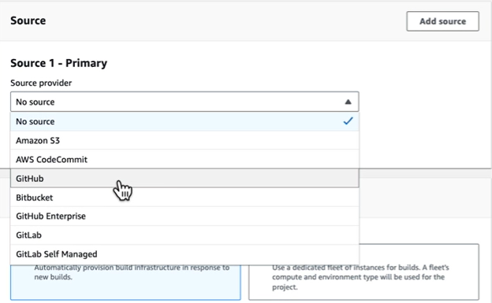

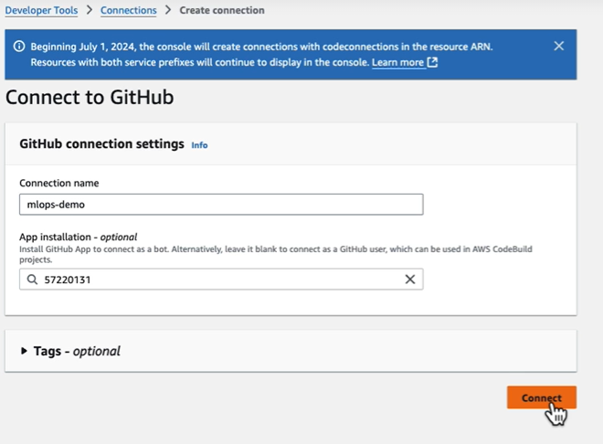

- Provisioning Model: On-demand
- Operating System: Linux
- Runtime: Standard
- Image: Latest AWS-managed image

Step 7: Connect GitHub to AWS
If GitHub has not been connected previously:
- Select Manage Source Credentials.
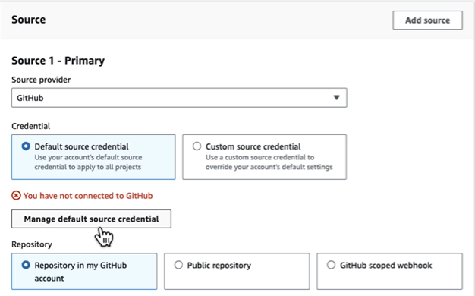
- Choose GitHub App (recommended).
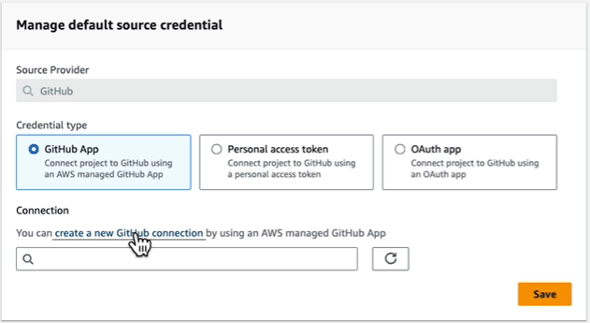
- Click Create a New GitHub Connection.
- Provide a connection name.

- Click Connect to GitHub.
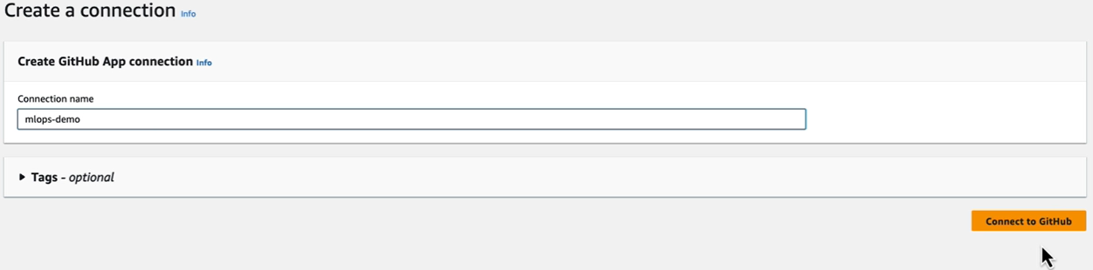
- Install and authorize the AWS Connector for GitHub.
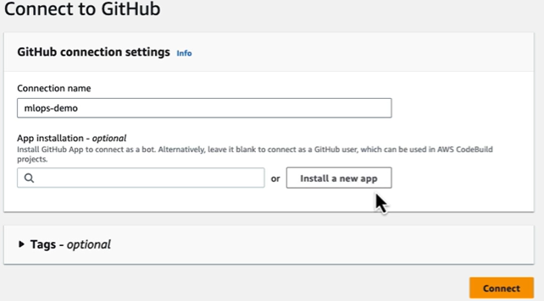
- Save the connection.
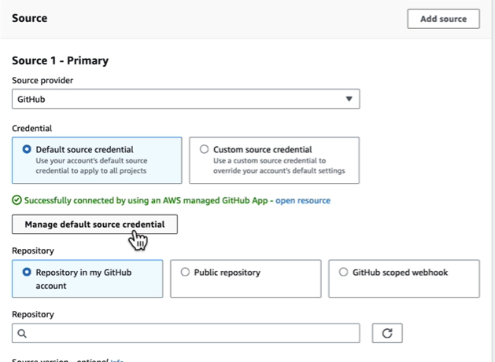
Once connected, AWS can securely access your GitHub repositories.

Step 8: Select the Repository
- Provide the repository URL.
- Example:
https://github.com/<username>/codebuild-demo

- CodeBuild will download the source code from this repository during every build.

Step 9: Configure Build Settings
Use the following configuration:
- AWS Managed Build Image
- Linux Operating System
- Latest Standard Runtime
- Auto-generated Service Role
- Build specification from repository (buildspec.yml)
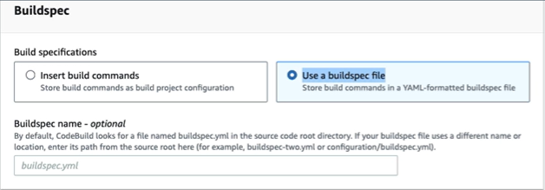
- Artifacts: No Artifacts (for this demonstration)
Click Create Build Project.

Step 10: Start the Build
Select the project and click Start Build.
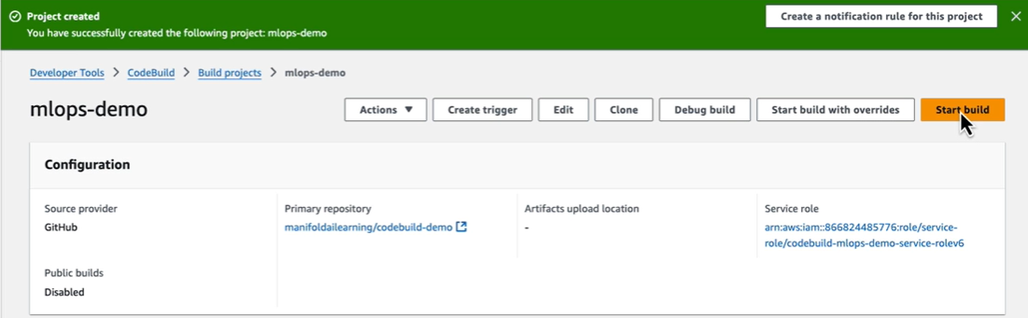
AWS CodeBuild begins the build process by:
- Downloading the source code
- Provisioning the build environment
- Installing dependencies
- Executing build commands
- Running post-build tasks
- Uploading artifacts (if configured)

Step 11: Resolve Permission Errors
If the build fails with a GitHub connection or authorization error, update the CodeBuild service role.
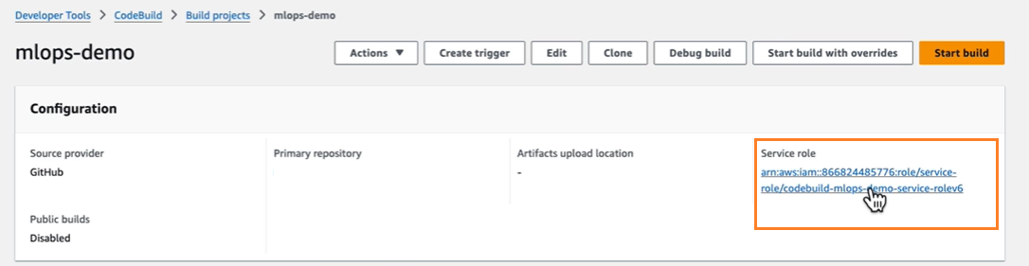
Navigate to:
IAM → Service Role → Add Permissions
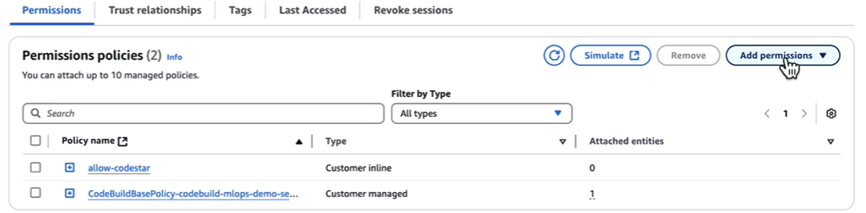
Create an inline policy.
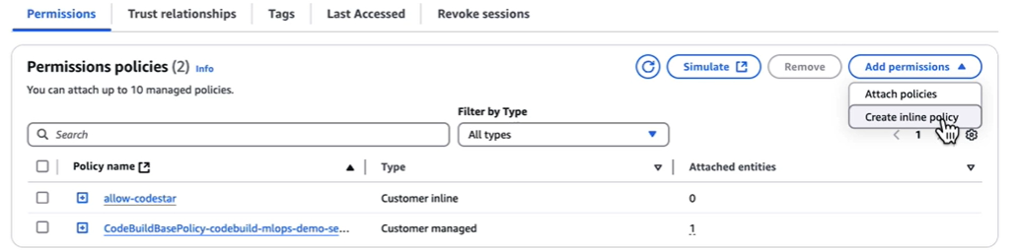
Configure:
- Service: CodeStar Connections
- Actions: All CodeStar Connection Actions
- Resources: All Resources

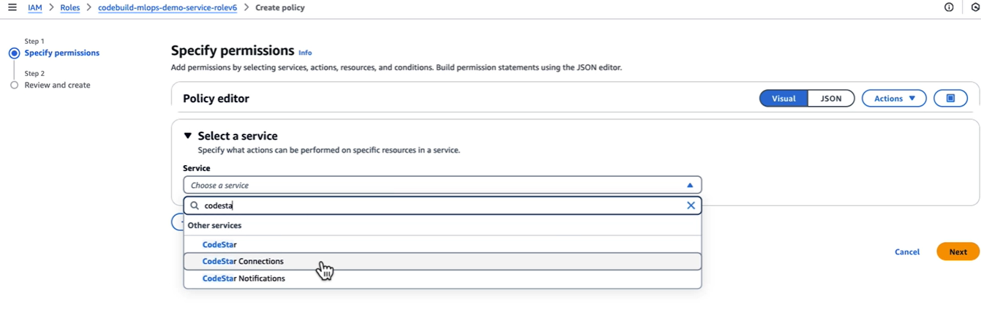

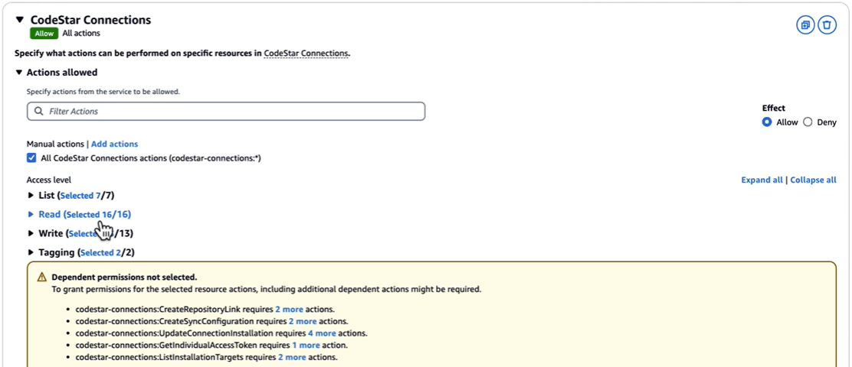

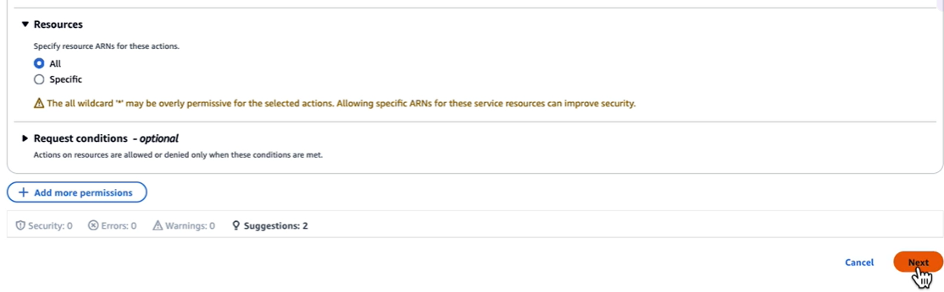
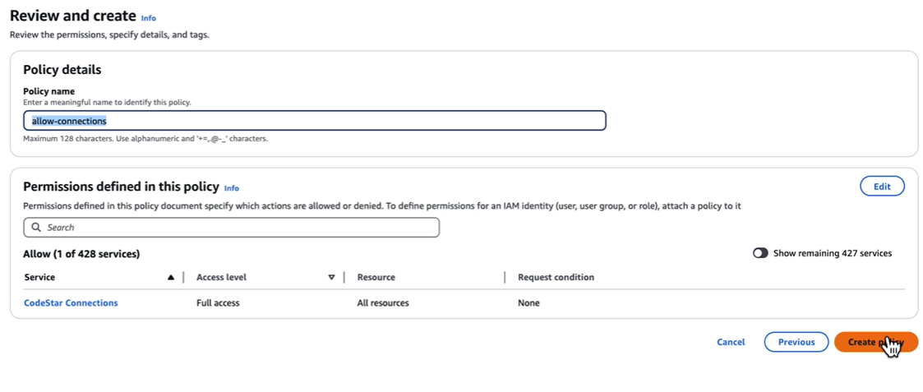
- Assign a policy name such as:
  - AllowConnection
- Save the policy.
  - Retry the build.
- The build should now complete successfully.

Step 12: Monitor Build Execution
During execution, CodeBuild displays detailed logs for each phase.
Typical phases include:
- Submitted
- Queued
- Provisioning
- Download Source
- Install
- Pre-build
- Build
- Post-build
- Upload Artifacts
- Completed
Each phase provides logs that help troubleshoot issues during the build process.

Step 13: Understanding the buildspec.yml File
The buildspec.yml file defines the build workflow.
It contains:
- Environment variables
- Runtime versions
- Install commands
- Pre-build commands
- Build commands
- Post-build commands
- Artifact configuration
A simple example:
version: 0.2

phases:
install:
commands:
- echo Installing dependencies

pre_build:
commands:
- echo Preparing build

build:
commands:
- echo Building application

post_build:
commands:
- echo Build completed
Whenever a build starts, CodeBuild automatically reads this file and executes the commands in each phase.

Summary
In this hands-on exercise, you successfully:
- Created a GitHub repository
- Initialized a local Git repository
- Pushed source code to GitHub
- Connected GitHub with AWS CodeBuild
- Created a CodeBuild project
- Configured a managed build environment
- Executed a build using buildspec.yml
- Resolved IAM permission issues using CodeStar Connections
- Reviewed build logs and execution phases
This workflow f

